Question: As you read through these pages, we recommend you think carefully about at least a few of the methods from each section. How could these methods be useful to things you have done previously? How could they be useful in work that you plan to do in the future? Why should the students in our PHBS sequence on Computational Economics and Finance want to learn them?

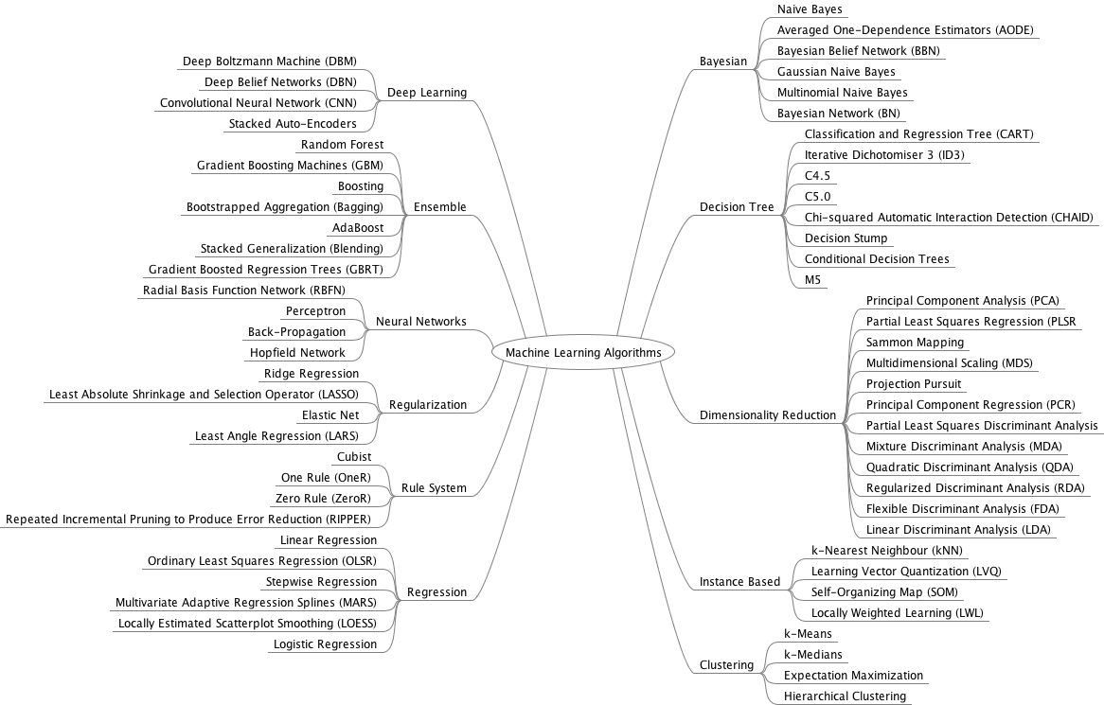

**Picture from** [**https://github.com/Bladefidz/machine-learning**](https://github.com/Bladefidz/machine-learning)

**-COMMON CHARACTERS**

-loss function central: reveal preference

-Prediction is usually fragile while theoretical model is robust

**- INTEREST TOPIC**

- Prediction: Pivotal decision based on some sort of prediction

- People left to predict on their own: Behavioral economics

- Data at arms length: Build model via ML tools

- Decision aid: Can compare human decisions and machine predictions

**- MACHINE LEARNING VS ECONOMETRICS**

**(From https://www.youtube.com/watch?v=eD758rKwQmA&t=1661s)**

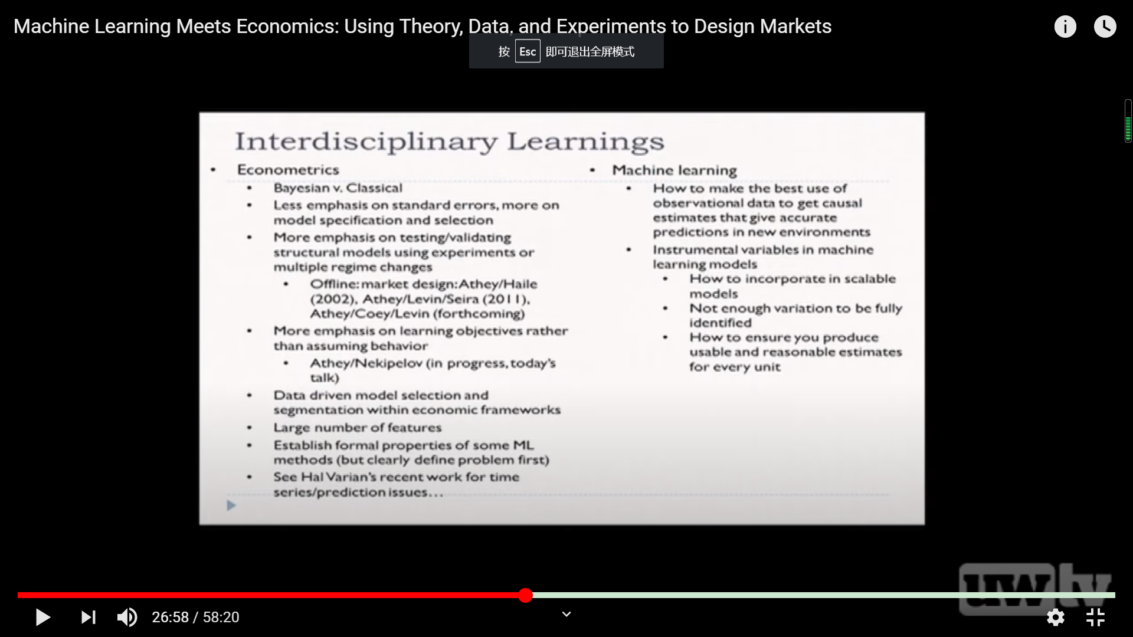

Many of these topics flourished **in finance**, because

- in part finance is focusing on prediction.

-

- you have out of sample thing you are testing on: in finance, it’s the next year data.

Compare to coefficient estimate quality, prediction accuracy is more observable.

- ML advantage: decrease the reflexively chosen X variables and let the data tell

- put structure on investor sentiment? In asset pricing

(AFA Lecture: Machine Learning and Prediction in Economics and Finance: Sendhil Mullainathan, Harvard University <https://www.youtube.com/watch?v=xl3yQBhI6vY>)

**-Classification:**

Widely used in many areas in economics problems, especially in finance area.

For a large variety of input X features, use your ML classification model to return a 0-1(or more 0123…in other new method) y variables identify which type does the sample belongs to.

There are some commonly used classification methods:

**KNN：**K Nearest neighbor, first find K nearest neighbors of the point X, then figure out what class most of them pertain to, and finally classify X in that particular class. The value of K is important, too large or too small K will cause underfitting or overfitting problem. This method is simple and straightforward, however, it is intensive both in computation and storage. Sometimes we can use this method as a procedure of feature engineering.

**SVC(SVM/SVR):** Support vector classifier, try to find a separating line that maximizes the distance between the margin of different classed. For a non-linear decision boundary, we can change the line to a curve or hyperspace by changing the core function.

**Decision Tree:** take one feature of X into consideration each time. First divide the whose X into two parts according to one certain feature of X, and then repeat doing that for each parts until getting the max depth or finishing that classification. The depth of the tree is important, too large or too small depth will cause overfitting or underfitting problem.

Question with the format of **“Whether or not”** in economics & finance can always be suitable in this method.

. Identify whether a specific individual loan will default or not (or other risk management area)

. Whether President Trump will reelection

. Whether the AAPL stock will rise or fall tomorrow or after the release of its statements (similarly as the other investment area)

. Whether there exists the crowding out effects for government to establish fiscal policy in different situation shown as the feature set of economics indicates.

Although due to database limitation we now cannot fulfill the overall project listed above, but as the data cumulates with time passing by, it will become more and more likely to appear in top journals.

**- Regression**

No need to say too much. As you can see, it is the most common way economist conduct their empirical research and how econ/fin students get their degree. It can actually give back both directional and quantitative information. We all study econometrics, and for machine learning users, they adjust some of the kernel in the original method and make the model fit the data more closely (Lasso, Ridge).

. The predict model of Singapore house price.

. Whether going for high education enlarge the workers salary.

You may think there is some overlap from the previous classification. Yes, it does. For example, Logit/Probit and other regression model can also be used for classification. Those are tools which can be used flexibly depending on your need.

We PHBS has a master of finance(Fintech) program. Usually it’s a good idea for them to replace the traditional econometrical regression to ML one and acquire something new in their graduation thesis.

**- Clustering**

This is not a traditional X-y analysis method. This time you have n data point X1,X2,…Xn with k different features, and your task is to identify some groups for this X. Note that in this case k is allowed to be bigger than n to increase your accuracy. The difference between clustering and classification is that, usually the latter one is supervised learning and we know the required group labels (Yes/No/…) and numbers (usually 2), but in clustering you need to first get the different groups and then figure out what is the meaning of the group.

Just provide a very simple example here for you to understand. If we collect the personal information and characteristics in PHBS students and conduct a clustering, it is very likely that the TA in this class will be classified together. Cause we’re all RA in SIQEF and try to get a PhD in future, also showing some scholar temperament.

. Walmart divide their customers in different groups according to their info and buying data.

. Ping-An insurance company collect people’s data (gender, age, deposit, salary, etc.) to design and provide different products accordingly.

. Scout which stock accounts have similar behaviors to infer whether the account owner has insider trading

. Analyze the linkage of product prices in the macro economy

. Sector rotation and statistical arbitrage

. Government design different development strategies for different groups of city divided by their different locations, industry, GDP and other features.

. Divide people into different social stratum according to wealth, salary, education background and other features. (You can have a lot of social imbalance and wealth differentiation topics after that.)

. Default clustering risk management

**- Dimensionality Reduction**

Mainly used as the first step before applying those above methods when you have so many X variables and cannot make use all of them for simplicity. Related to Feature Engineering method in CS. The most common way in ‘sklearn’ is to process PCA/LDA/FA to fit the data in order to combine different artificial index to avoid subject influence in this statistical caliber. You will get small number of meaningful main aspects from the huge feature X set.

. Transform a microeconomics signal as a sparse combination of Ricker wavelets.

. Factor analysis and PCA in stock and bond markets (return estimation)

. ICA in macroeconomics business cycle.

**- COMMON METHOD**

**- Model Selection**

Usually in a machine learning program, we conduct a series of ML method and get many models, which can be used for further prediction. To improve our accuracy of prediction, we need to build a method and a standard for testing and evaluating different types of model. Usually all the multiple ML method projects or papers will provide this step in the end.

**- Preprocessing**

. A method to deal with unstructured data. Usually exist in every research. But it actually cost the majority of time in your project. You need to look deeper into the data and try to combine some of your own idea to preprocess the result.

**Paper:**

**Type 1: Overall guidance**

Pedregosa, F., Varoquaux, G., Gramfort, A., Michel, V., Thirion, B., Grisel, O., ... & Vanderplas, J. (2011). Scikit-learn: Machine learning in Python. *the Journal of machine Learning research*, *12*, 2825-2830.

<http://www.jmlr.org/papers/volume12/pedregosa11a/pedregosa11a.pdf>

Buitinck, L., Louppe, G., Blondel, M., Pedregosa, F., Mueller, A., Grisel, O., ... & Layton, R. (2013). API design for machine learning software: experiences from the scikit-learn project. *arXiv preprint arXiv:1309.0238*.

[**https://arxiv.org/pdf/1309.0238.pdf?source=post_elevate_sequence_page---------------------------**](https://arxiv.org/pdf/1309.0238.pdf?source=post_elevate_sequence_page---------------------------)

Brownlee, J. (2017). How Much Training Data is Required for Machine Learning. *Machine Learning Mastery.[Online] Available: https://machinelearningmastery. com/much-training-data-requiredmachine-learning/[2018, May 25]*.

**https://machinelearningmastery.com/much-training-data-required-machine-learning/**

Athey, S. (2018). The impact of machine learning on economics. In *The economics of artificial intelligence: An agenda* (pp. 507-547). University of Chicago Press.

<https://www.gsb.stanford.edu/sites/gsb/files/publication-pdf/atheyimpactmlecon.pdf>

Abadie, A., & Kasy, M. (2019). Choosing among regularized estimators in empirical economics: The risk of machine learning. *Review of Economics and Statistics*, *101*(5), 743-762.

<https://www.mitpressjournals.org/doi/full/10.1162/rest_a_00812>

Korobilis, D. (2018). Machine learning macroeconometrics: A primer. *Available at SSRN 3246473*.

<https://papers.ssrn.com/sol3/papers.cfm?abstract_id=3246473>

Coulombe, P. G., Leroux, M., Stevanovic, D., & Surprenant, S. (2019). *How is Machine Learning Useful for Macroeconomic Forecasting?* (No. 2019s-22). CIRANO.

<https://www.stevanovic.uqam.ca/GCLSS_ML_MacroFcst.pdf>

Some useful guidance from PHBS: Prof. Jaehyuk Choi and Prof. Xianhua Peng

<https://github.com/PHBS/RM-F1/blob/master/files/quant_topics.md>

**Type 1: Classification**

Moritz, B., & Zimmermann, T. (2016). Tree-based conditional portfolio sorts: The relation between past and future stock returns. *Available at SSRN 2740751*.

[**https://papers.ssrn.com/sol3/papers.cfm?abstract_id=2740751**](https://papers.ssrn.com/sol3/papers.cfm?abstract_id=2740751)

**(Use decision tree, combining with normal regression)**

**Type 2: Regression**

**Type 3: Clustering**

Saâdaoui, F. (2012). A probabilistic clustering method for US interest rate analysis. *Quantitative Finance*, *12*(1), 135-148.

<https://www.tandfonline.com/doi/full/10.1080/14697681003591712?scroll=top&needAccess=true>

Das, N. (2003, August). hedge Fund classification using K-means clustering Method. In *9th International Conference on Computing in Economics and Finance* (pp. 11-13).

<https://www.researchgate.net/profile/Nandita_Das8/publication/24128136_Hedge_Fund_Classification_using_K-means_Clustering_Method/links/5956d0eba6fdcc2beca393d6/Hedge-Fund-Classification-using-K-means-Clustering-Method.pdf>

Marsili, M. (2002). Dissecting financial markets: sectors and states. *Quantitative Finance*, *2*(4), 297-302.

<https://www.tandfonline.com/doi/pdf/10.1088/1469-7688/2/4/305>

Durante, F., Pappadà, R., & Torelli, N. (2014). Clustering of financial time series in risky scenarios. *Advances in Data Analysis and Classification*, *8*(4), 359-376.

<https://link.springer.com/article/10.1007/s11634-013-0160-4>

León, C., Kim, G. Y., Martínez, C., & Lee, D. (2017). Equity markets’ clustering and the global financial crisis. *Quantitative Finance*, *17*(12), 1905-1922.

<https://www.tandfonline.com/doi/full/10.1080/14697688.2017.1357970>

**Type 4: Machine Learning regression for Econometrics**

-replace or upgrade the traditional empirical econometrics

Charpentier, A., Flachaire, E., & Ly, A. (2018). Econometrics and machine learning. *Economie et Statistique*, *505*(1), 147-169.

<https://content.sciendo.com/view/journals/dim/1/2/article-p75.xml>

Kauffman, R. J., Kim, K., Lee, S. Y. T., Hoang, A. P., & Ren, J. (2017). Combining machine-based and econometrics methods for policy analytics insights. *Electronic Commerce Research and Applications*, *25*, 115-140.

<https://ink.library.smu.edu.sg/cgi/viewcontent.cgi?referer=https://scholar.google.com.tw/&httpsredir=1&article=4731&context=sis_research>

Cornec, M. (2009). *Probability bounds for the cross-validation estimate in the context of the statistical learning theory and statistical models applied to economics and finance* (Doctoral dissertation).

<https://pastel.archives-ouvertes.fr/tel-00530876/document>

Wager, S., & Athey, S. (2018). Estimation and inference of heterogeneous treatment effects using random forests. *Journal of the American Statistical Association*, *113*(523), 1228-1242.

<https://www.tandfonline.com/doi/pdf/10.1080/01621459.2017.1319839>

Hansen, C., & Kozbur, D. (2014). Instrumental variables estimation with many weak instruments using regularized JIVE. *Journal of Econometrics*, *182*(2), 290-308.

<https://www.sciencedirect.com/science/article/pii/S0304407614000918>

Belloni, A., Chen, D., Chernozhukov, V., & Hansen, C. (2012). Sparse models and methods for optimal instruments with an application to eminent domain. *Econometrica*, *80*(6), 2369-2429.

<https://users.nber.org/~dlchen/papers/Sparse_Models_and_Methods_for_Optimal_Instruments_ECTA.pdf>

Grimmer, J., Messing, S., & Westwood, S. J. (2017). Estimating heterogeneous treatment effects and the effects of heterogeneous treatments with ensemble methods. *Political Analysis*, *25*(4), 413-434.

<http://pages.shanti.virginia.edu/PolMeth/files/2013/07/GrimmerMessingWestwood.pdf>

Chernozhukov, V., Chetverikov, D., Demirer, M., Duflo, E., Hansen, C., Newey, W., & Robins, J. (2018). Double/debiased machine learning for treatment and structural parameters.

<https://academic.oup.com/ectj/article/21/1/C1/5056401>

**Type 5: Machine Learning regression for microeconomics**

-

Brathwaite, T., Vij, A., & Walker, J. L. (2017). Machine learning meets microeconomics: The case of decision trees and discrete choice. *arXiv preprint arXiv:1711.04826*.

<https://arxiv.org/pdf/1711.04826.pdf>

Chalfin, A., Danieli, O., Hillis, A., Jelveh, Z., Luca, M., Ludwig, J., & Mullainathan, S. (2016). Productivity and selection of human capital with machine learning. *American Economic Review*, *106*(5), 124-27.

<https://academic.oup.com/ectj/article/21/1/C1/5056401>

**Type 5: Advanced Machine Learning skills**

Liu, S., Oosterlee, C. W., & Bohte, S. M. (2019). Pricing options and computing implied volatilities using neural networks. *Risks*, *7*(1), 16.

https://arxiv.org/pdf/1901.08943.pdf

some other paper from <http://econ-neural.net/>

official scikit-learn package description

https://github.com/scikit-learn/scikit-learn

**Examples**

<https://www.dezyre.com/article/top-10-machine-learning-projects-for-beginners/397>

You will find some interesting ideas and projects carried by PHBS students in

<https://github.com/PHBS/MLF/blob/master/Project.md> , and also other useful materials provided by Prof. Choi.

**Direct Course Links**

**From:** <https://github.com/lazyprogrammer/machine_learning_examples>

**PyTorch:** Deep Learning and Artificial Intelligence (special discount link for full VIP course as of Apr 2020)

<https://www.udemy.com/course/pytorch-deep-learning/?couponCode=PYTORCHVIP>

**Tensorflow 2.0:** Deep Learning and Artificial Intelligence (VIP Content)

<https://deeplearningcourses.com/c/deep-learning-tensorflow-2>

**Cutting-Edge AI: Deep Learning in Python**

[https://deeplearningcourses.com/c](https://deeplearningcourses.com/c/cutting-edge-artificial-intelligence)

Data Quest URL :[Sales_Win_Loss data](https://www.ibm.com/communities/analytics/watson-analytics-blog/sales-win-loss-sample-dataset/) set from IBM’s Watson repository

<https://www.dataquest.io/blog/sci-kit-learn-tutorial/>

A group of interesting case to follow, including multiple machine learning project:

<https://github.com/scikit-learn/scikit-learn/tree/master/examples>

Forecasting ECB Yield curve

<https://www.youtube.com/watch?v=nakmpAQ6z-g&t=152s>

you can download relative data from

<https://www.ecb.europa.eu/stats/financial_markets_and_interest_rates/euro_area_yield_curves/html/index.en.html>